Blast From Your Past
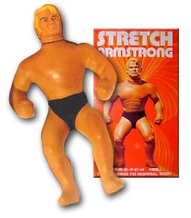
Objects that are special to us, become more than simple items, but things that can trigger memories, and powerful feelings. Your task is to select a toy or item from your past with meaning and explain its significance in your childhood and beyond.
Your reflection journal should be a minimum of 1 typed page (11 or 12 font). You should consider the questions below to include in your response. Be sure to write in complete sentences and to include specific details.
Recount
Include a picture/diagram of the item(s) you are writing about. Find an image on the internet or take your own picture.
Describe the item. Include the important features of it.
When did you receive it and why?
Why do you consider it to be significant or special?
Why did you want it? Did receiving it change you?

Making Connections
Make connections to as many areas as possible.
Explain what would happen if you lost it or how did you feel when you lost it?
Would you sell it on Ebay for the right price? Explain why or why not?
Relate this item or the feelings associated with it to any text, media, or real world situations.
Did you buy the object because of the commercial? Explain. Did the item live up to the expectations you had of it?
How would the object be different if it were designed/marketed today?
Application
What toys do you think people will remember from your generation? Why?
Predict what toys or types of toys will be popular in the future. (Be sure to back your predictions up with evidence)

